**Queuing System using PHP and MS Access Database**

1. Download the MS Access Database
2. Download the access database engine

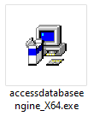

1. Set this to the php.ini

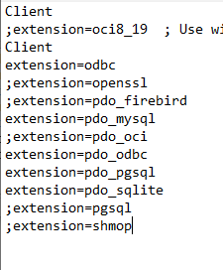

1. File location of database

